

**RESULTS FOR PILOT STUDY COGNITIVE SCIENCE – INNOVATION**

**PROFESSOR CATHAL OMADAGAIN**

**Paul Adubi Ayobamidele CI – Group 4**

**Title and Introduction:**

Title - "Investigating the Impact of Gender Composition on Group Innovation"

Research Question – “Does Group Gender Composition have a significant effect on the level of group innovation?”

Dependent Variable – “Level of Group Innovation”

Independent Variable – “Group Composition”

**Methodology:**

This study aimed to examine the influence of gender-based group composition on collective innovation, focusing on creativity and improvement across three distinct tasks: Password Creation, Logo Redesign, and the generation of Innovative Ideas for space enhancement. The groups were stratified into three categories: a female-dominant group (4 females, 1 male), a balanced group with an equal distribution of males and females (3 males, 3 females), and a male-dominant group (4 males, 2 females). The participants maintained their group composition throughout the tasks, and random distribution mitigated conformity effects.

**Recruitment:**

All participants were recruited through non-probability sampling Confidence Sampling and Snowballing Sampling

**Experiment and Data Collection:**

The experiment was conducted in an open hall, where the participants were randomly distributed to conform to the group composition. We ended up with three groups for all three tasks.

|  |  |
| --- | --- |
| **Intended Design** | **Actual Design** |
| Group One – 3 Males 4 Females  Group Two – 3 Males 3 Females  Group Three – 4 Males 3 Females | Group One – 3 Males 4 Females  Group Two – 2 Males 4 Females  Group Three – 4 Males 3 Females |

**Data Collection**

The data collection was divided into two:

1. The “***sentiment analysis***” of participants after each task in terms of
   * 1. How they perceive the ***ease of communication*** and ***freedom of expression*** across each group they were randomly assigned to per task.
     2. How they perceived themselves to easily come up with ***innovative ideas***.

This data was obtained from each participant after the end of the task. The image in ***Figure 1.0*** below illustrates an example of the survey questions presented each participant after each task.

1. The **evaluators** score: All the entries per group was obtained for each of the three tasks and given to the evaluators. A summary was supplied to the evaluators to provide them with context about what the task was about, what was expected from each group and what we expected from them as evaluators. The image ***in Figure 1.1*** below further illustrates instances of the survey questions presented to evaluators.

**Qualtrics**

All data were collected by survey through Qualtrics (more information in the methodology).

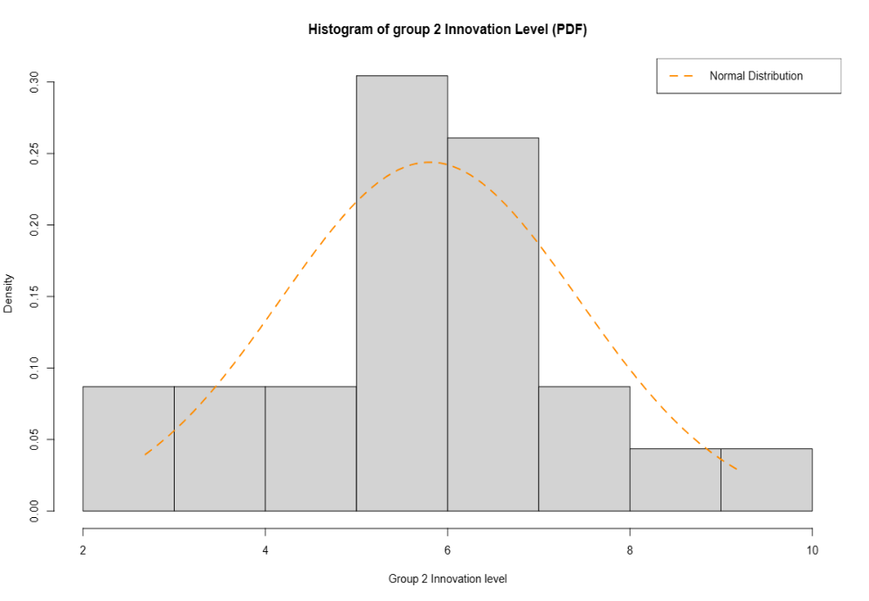

Chart 1.0:The Histogram of Group 2 Innovation scores

**Data Analysis**

**Sample Size**

**Sentiment Analysis –** 20 participantsfor each task.

**Evaluation Analysis** – 23 Participants

**Evaluators Score Analysis:** This provided us insights into which groups were innovation, but more importantly if the differences in group innovation were indeed statistically significant and not just that they were observed by mere coincidence.

**Test for Normality**

The Shapiro-Wilk Test was adopted to test the normality of the data obtained.

**Table 1.0**: The result of Normality Test

|  |  |  |  |
| --- | --- | --- | --- |
|  | **Group 1 – Innovation Level** | **Group 2 – Innovation Level** | **Group 3 – Innovation Level** |
| **W**  **p-value** | 0.96048  0.473 | 0.97329  0.7671 | 0.97026  0.6952 |

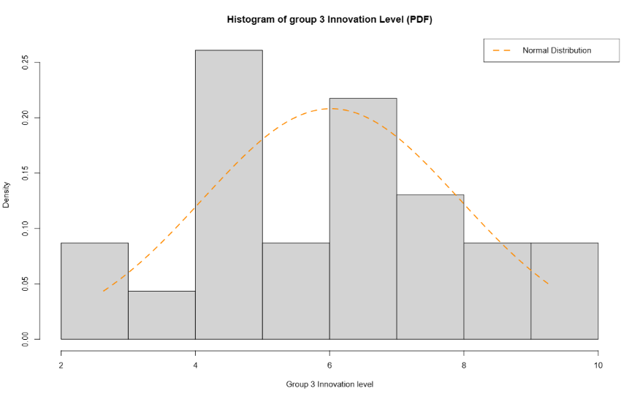

Based on the Shapiro-Wilk tests, there is no strong evidence to suggest that the innovation scores for the three groups are not significantly different from a normal distribution. Hence, we can perform an inferential test such as the t-test. The chart 1.0, 2.0, 3.0 below shows the histogram of each of the groups’ innovation level with the Probability Density Function of a normal distribution with the same mean and standard deviation as the sample data. Chart 2.0:The Histogram of Group 3 Innovation scores

A new variable was created by computing the average innovation score for each group based on the creativity and improvement scores for each task. ***Table 1.0*** shows the first six observations of the Computed Innovation Level per group.

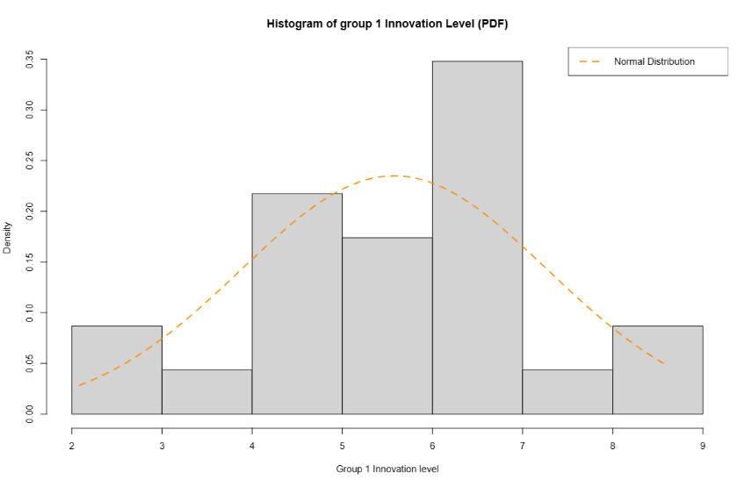

­­­­­­­­­Chart 3.0:The Histogram of Group 1 Innovation

**Table 2.0:** The table of Group Innovation Level – the first six observations.

|  |  |  |
| --- | --- | --- |
| **Group 1 – Innovation Level** | **Group 2 – Innovation Level** | **Group 3 – Innovation Level** |
| 4.983  4.350  2.083  6.917  2.167  8.567 | 4.983  6.367  6.300  5.917  2.683  5.817 | 4.967  6.350  4.233  6.667  2.633  7.983 |

**Inferential Analysis**

**T Test Result**

Based on the t-tests, there is no strong evidence to suggest significant differences in the mean innovation scores between any pair of groups. The p-values are all greater than the conventional significance level of 0.05.

In the context of the experiment, this implies that, according to the collected data, the group compositions (female-dominant, balanced, and male-dominant) do not seem to have a statistically significant impact on the level of group innovation.

**Table 3.0:** The table presenting the Welch Two Sample t-test.

|  |  |  |  |
| --- | --- | --- | --- |
|  | **Group 1 – Group 2** | **Group 1 – Group 3** | **Group 2 – Group 3** |
| **t statistic**  **df**  **p-value**  **CI (95%)** | -0.4599  43.939  0.6478  [-1.2168, 0.7646] | -0.8320  43.368  0.4099  [-1.5205, 0.6321] | -0.4152  42.939  0.6801  [-1.2776, 0.8414] |

**ANOVA Result**

**Table 4.0:** The table presenting the Analysis of Variance (ANOVA).

|  |  |  |  |  |  |
| --- | --- | --- | --- | --- | --- |
|  | **df** | **Sum Sq** | **Mean Sq** | **F value** | **Pr (> F)** |
| **Group**  **Residuals** | 2  66 | 2.27  203.06 | 1.135  3.077 | 0.369 | 0.693 |

Given the p-value of 0.693, you would likely conclude that there is no statistically significant difference in means between the groups. The F-statistic of 0.369 further suggests that the variability between groups is not significantly different from the variability within groups.

**Descriptive Analysis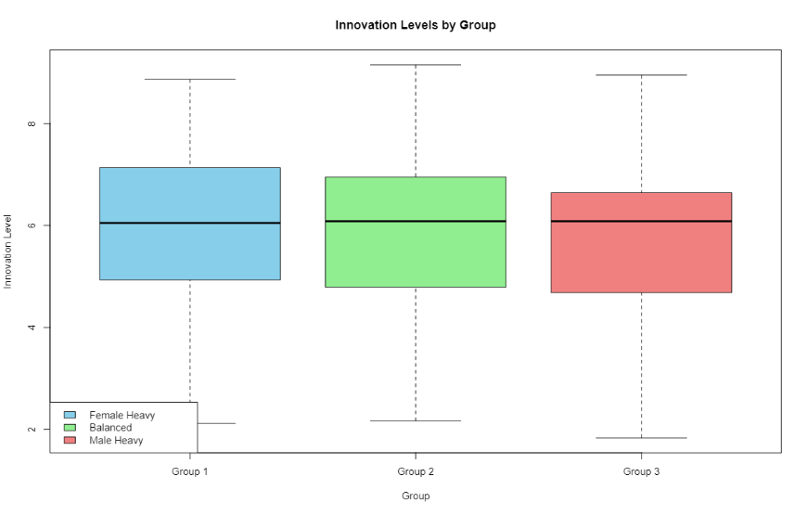:** The chart 4.0 below illustrates the boxplot of the groups’ innovation level. Here we see that although all three groups have same median level of innovation, it happens that Group 3 (Male dominant) has the lowest minimum level of innovation level compared to other groups, this illustrates that the male dominant group tend to score more lower innovation point than other groups. Table 5.0 shows that mean and standard deviation of the groups.

**Chart 4.0**: Boxplot of Innovation levels by group

**The Sentiment Analysis:** This analysis delved into participants' perceptions regarding both communication ease and individual innovation across distinct groups. Two key variables were employed to gauge participant satisfaction: the level of communication within each group and the perceived innovation level of each participant across the three groups for each task. The computation of overall satisfaction for each group involved averaging the scores for ease of communication and individual innovation. The results, as presented in Table 6.0, 7.0, 8.0 indicate that Group 1 (Female dominant group) exhibits the highest mean overall satisfaction, while Group 3 (Male dominant group) demonstrates the lowest mean overall satisfaction for each task respectively.

**Table 5.0:** The table presenting the overall group mean innovation level.

|  |  |  |  |
| --- | --- | --- | --- |
|  | **Group-1 Innovation level** | **Group-2 Innovation level** | **Group-3 Innovation level** |
| **mean** | 5.5768 | 5.8029 | 6.0210 |
| **sd** | 1.6976 | 1.6356 | 1.9165 |

**Table 6.0:** The table presenting the mean overall satisfaction for task one.

|  |  |  |  |
| --- | --- | --- | --- |
| **Group** | **Mean Overall Satisfaction** | **Mean Ease of communication** | **Mean Perceived Level of Innovation** |
| **1** | 6.43 | 6.71 | 6.14 |
| **2** | 6.58 | 6.83 | 6.33 |
| **3** | 6.29 | 6.29 | 6.29 |

**Table 7.0:** The table presenting the mean overall satisfaction for task two.

|  |  |  |  |
| --- | --- | --- | --- |
| **Group** | **Mean Overall Satisfaction** | **Mean Ease of communication** | **Mean Perceived Level of Innovation** |
| **1** | 5.10 | 5.20 | 5.00 |
| **2** | 6.50 | 6.40 | 6.60 |
| **3** | 6.42 | 6.67 | 7.17 |

**Table 8.0:** The table presenting the mean overall satisfaction for task three.

|  |  |  |  |
| --- | --- | --- | --- |
| **Group** | **Mean Overall Satisfaction** | **Mean Ease of communication** | **Mean Perceived Level of Innovation** |
| **1** | 6 | 6 | 6 |
| **2** | 6.33 | 6.5 | 6.17 |
| **3** | 6.64 | 6.67 | 6.67 |

Chart 5.0, 6.0 and 7.0 illustrates the distribution of overall satisfaction scores across three different groups per task in our study. Each box represents a group, displaying the median (central line) and interquartile range (box). The whiskers extend to the minimum and maximum values within a permissible range, while any data points beyond the whiskers are considered outliers.

